Thyroid Pathology
The thyroid gland is located in a fairly accessible and visible part of the body. We will approach thyroid pathology in a systematic fashion, looking at:
I. Anatomy
- Understanding the anatomical relations helps you to work out the clinical presentations of thyroid enlargement (goitre).
II. Function
- The function of the thyroid gland relates to the type of parenchymal cells it contains
- It is also important to appreciate that the thyroid gland is an endocrine organ, and therefore part of a system of regulatory mechanisms
III. Clinicopathologic Correlates
- This section helps you correlate the clinical manifestations of thyroid pathology with specific disease entities
- Build on this framework by reading about the specific pathogenesis, clinical features and morphologic features of each condition

Anatomy
The relations of the thyroid gland are particularly important. Think about thyroid enlargement what gets compressed? This gives rise to the clinical presentation.

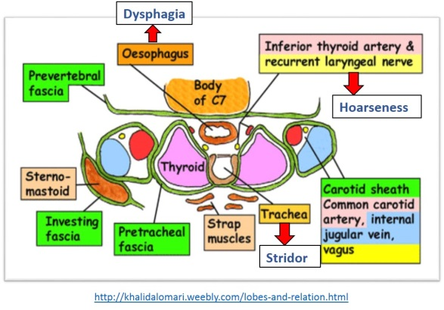

Reference websites for thyroid anatomy:
1.http://khalidalomari.weebly.com/lobes-and-relation.html
2.http://fitsweb.uchc.edu/student/selectives/Luzietti/Thyroid_anatomy.htm (You can peel away the layers of the neck)

Function
The main functions of the thyroid gland are brought about by the TWO main parenchymal cell types:
1. Follicular cells –> Thyroid hormones T3 (tri-iodothyronine) and T4 (tetra-iodothyronine/thyroxine)
- Regulate basal metabolic rate (think about the clinical signs and symptoms of hyper/hypo thyroidism)
- Growth and development, especially of the central nervous system (read about Cretinism – hypothyroidism in infancy or childhood)
- The free (unbound) hormones are the metabolically active forms

More on T3 and T4 production: http://fitsweb.uchc.edu/student/selectives/Luzietti/Thyroid_hormones.htm

2. Parafollicular C cells –> Calcitonin
- Calcium metabolism – maintains calcium homeostasis (generally, calcitonin opposes the effects of Parathormone)

Regulation of T3 and T4 production
As an endocrine organ, the thyroid gland is subject to secondary (pituitary – TSH) and tertiary (hypothalamus – TRH) control mechanisms that all endocrine organs are subject to. This is the hypothalamo-pituitary axis.

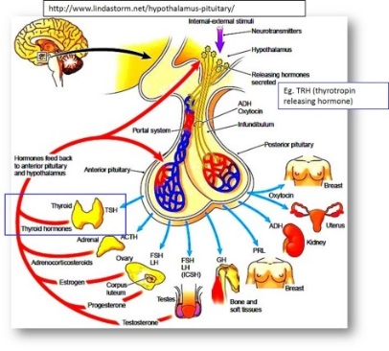
Mindmap - Thyroid anatomy and function: http://blog.nus.edu.sg/pathotest2/chapter-thyroid-pathology/ii-function/
Clinicopathologic Correlates
Here are TWO main clinical manifestations of thyroid disease:
1. Enlargement (non-neoplastic or neoplastic)
- Determined by history, clinical examination and imaging
2. Abnormal function (hyper or hypothyroidism)
- Assessed by blood investigations of various hormone levels (free T3 Free T4, TSH)
Remember, these two can co-exist (e.g. Graves disease – think about what the clinical presentation is).

- The Aetiology of thyroid conditions is widely variable, but the few that are more common and important are as featured in your lecture notes:
- Congenital conditions (e.g. hypoplasia, ectopic thyroid)
- Hyperplasia (simple or nodular hyperplasia due to decreased iodine availability)
- Immune related (autoimmune, or other mechanisms of thyroiditis)
- Neoplasms
In clinicopathologic correlation, we would ask some questions. E.g. What condition is more likely to cause diffuse enlargement? Which causes a solitary nodule?

Mindmap - Clinicopathologic correlation:
http://blog.nus.edu.sg/pathotest2/chapter-thyroid-pathology/iii-clinicopathologic-correlates/

Talking POTS and slides
http://blog.nus.edu.sg/pathotest2/chapter-thyroid-pathology/thyroid-iv-talking-pots-and-slides/

Quiz
http://blog.nus.edu.sg/pathotest2/chapter-thyroid-pathology/v-thyroid-quiz/

