Breast Pathology
Overview and Approach
What is the breast?
- Modified skin appendage (sweat gland) –
  - Terminal duct lobular unit – small ducts and lobules lined by specialized bilayered epithelium
    - Myoepithelial – outer, against basement membrane
    - Epithelial- inner – facing lumen – many epithelial proliferations and neoplasms arise from this
  - Specialised intralobular stroma
    - Can become neoplastic and induce proliferation of epithelial cells too develop fibroepithelial neoplasms (eg. fibroadenoma, phyllodes tumour)
  - These two components are hormonally responsive and may undergo morphologcal changes during various parts of the menstrual cycle, as well as during lactation
Large ducts and lactiferous ducts – larger ducts also lined by bilayered epithelium, the latter open into the nipple. Benign, in-situ and malignant neoplasms can also arise from these (may cause bloody nipple discharge)
Functions of the breast
- Produce milk and nourishment for offspring
- Provide immunological source of protection for offspring
Important clinical considerations
- As breast cancer is the commonest malignancy in women, one of the key questions when approaching a female patient with a breast complaint is: Is this malignant?
- Even benign lesions (eg. benign epithelial proliferations) may carry an increased risk of malignancy, so these need to be followed-up
- Family history and past history are very important when evaluating a patient for possible breast malignancy
- The triple test – a combination of clinical evaluation (History and physical examination); diagnostic imaging and tissue biopsy, is the mainstay of the diagnostic approach to breast cancer.

Main disease categories
- Inflammatory/Infectious
- Traumatic
- Benign epithelial lesions
- Arise from TDLU, some have increased risk of malignancy
- These are subdivided into Proliferative vs Non-proliferative lesions; with or without atypia
- Neoplasms
- Benign vs Malignant (in-situ vs invasive)
- Which component do they arise from – epithelium or stroma?
- These are often picked up early because of our National Breast Screening Programme
- Developmental disorders
- Hormone related conditions (eg. gynaecomastia in males)
Mindmaps;
http://blog.nus.edu.sg/pathotest2/breast-pathology/ii-main-diseases-of-the-breast/
I. Overview of conditions of the breast
II. Neoplasms of the breast:

Clinicopathologic Correlations
Refer to the table on the next page for examples of conditions and their clinical features.

Another very important clinical presentation is the asymptomatic patient with imaging abnormalities from breast screening.
- Why screen? – Detect smaller (earlier) lesions – threshold size for detection is around 1cm (compared to palpation which is around 2cm)
- 2 main parameters evaluated:
1. Densities
2. Calcifications (worrying: small, irregular, numerous, clustered; linear branching (DCIS))

Don’t forget Systemic symptoms too, which can occur in advanced disseminated malignancy; or infections, as well as hormonal or developmental conditions.

Mindmap: Main clinical presentations
http://blog.nus.edu.sg/pathotest2/breast-pathology/iii-clinicopathologic-correlation/

Figure out the underlying pathology for each lemon:
https://blog.nus.edu.sg/pathotest2/files/2017/01/knowyourlemonsdotcom-12signs-29d918y.png

Talking POTS and Slides
http://blog.nus.edu.sg/pathotest2/breast-pathology/iv-talking-pots-and-slides/

Quiz
http://blog.nus.edu.sg/pathotest2/breast-pathology/v-breast-pathology-quiz/

Real Life Case Example
See how a team of doctors manages a patient with a breast lump. At each step, think about what your role would be if you were the GP, or the medical officer in the specialist clinic
http://blog.nus.edu.sg/pathotest2/real-life-case-a-breast-mass/

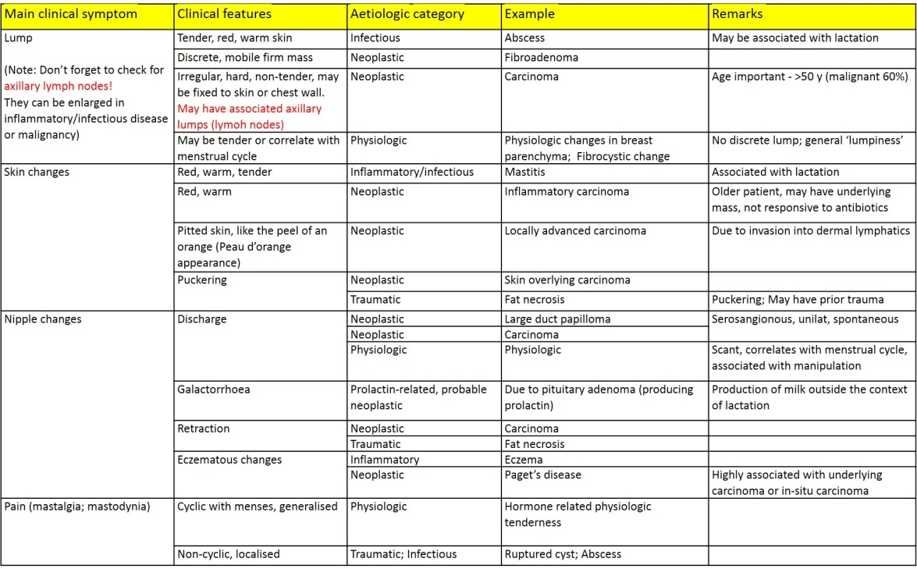
Table on Clinicopathologic Correlations

