Gastrointestinal tract
Main Function:
- To regulate the intake, processing and absorption of ingested nutrients and disposal of waste products.
- Several specific processes occur during the passage of food – movement (due to peristalsis of the gut), secretion, digestion, absorption and excretion
- All these processes must work well in order for the gut to achieve its ultimate role in the nutritional state of the body
Main function of specific Components
Oesophagus | Conduit between oral cavity and stomach
Stomach | Storage, acid and pepsin secretion for early digestion
Small bowel | Most of the action happens here. Digestion (enzymes provided by pancreas; bile acids for fat emulsification provided by liver) and absorption of nutrients.
Colon | Storage of digested material, small amount of water absorption

Clinicopathologic Correlates:
Structure and Function
Clinical manifestations of GI disease are closely related to its STRUCTURE and FUNCTION.
Structure
- Hollow organ – diseases cause ulceration, perforation, obstructions, bleeding
- Long tubular segments with attached adipose tissue –> possibility of mechanical twisting or telescoping
Function
- Responsible for absorption of ingested nutrients and excretion of waste – hence nutritional deficiencies can occur

Mindmap of Clinicopathologic correlates :
http://blog.nus.edu.sg/pathotest2/1670-2/git-ii-clinicopathologic-correlates/

Cardinal signs and symptoms
- Abdominal or chest pain – due to inflammation, obstruction (colic)
  - Altered ingestion of food – nausea, vomiting, dysphagia (difficulty in swallowing), or
anorexia (lack of appetite)
- Altered bowel movements – diarrhoea or constipation
  - Bleeding – Acute or chronic
Acute GI bleed can result in severe blood loss and hypotensive shock
Some characteristics of the bleeding / blood provide clues as to source (upper vs lower GIT).
Chronic bleed results more in anaemia – eg. fatigue, pallor, shortness of breath
Complications:
Acute
- Dehydration – if the GIT is not able to absorb water properly (this is a systemic condition arising from a GIT condition)
- Sepsis
- Hypotensive shock from GI bleeding
Chronic
- Malabsorption(malnutrition, deficiency states)
- Obstruction

Classification of disease
Simplest way is to use both aetiological and anatomical classifications
Anatomy: The GIT can be divided into Upper and Lower GIT. There are several schemes of division:
Upper GI tract – Mouth to Duodenum (Note: For upper GI bleed, usually regarding bleeding above DJ junction)
Lower GI tract – Distal duodenum to Anus

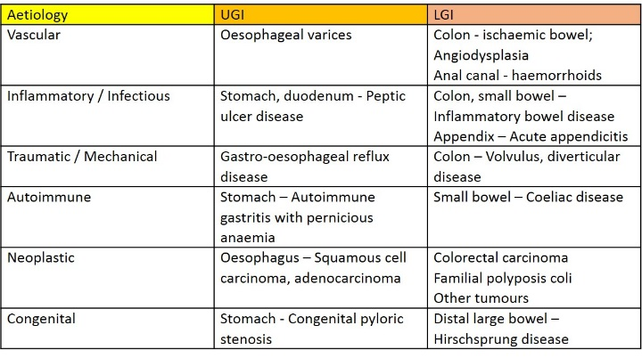
Aetiological classification (table only shows few condition):
Mindmap GIT diseases overview: http://blog.nus.edu.sg/pathotest2/1670-2/git-iii-classification-of-diseases/

GIT Tumours

The GIT is a good example of learning about neoplasms, in terms of:
1. Nomenclature
2. Progression of premalignant conditions to malignant tumours (eg. Adenoma – Carcinoma sequence)
3. Grading and Staging of malignant tumours
- Where to start? The main types of neoplasms in the GIT follow the layers of the gut wall – so revise your histology and look at the layers one by one.

- Pathology may arise from any of the layers – most tumours arise from the mucosa and the histologic type depends on the native mucosa, which the video will elaborate on.

Mindmap Crash course on GIT tumours: http://blog.nus.edu.sg/pathotest2/1670-2/git-iv-git-tumours-crash-course/

Talking Pots and Slides http://blog.nus.edu.sg/pathotest2/1670-2/v-git-talking-pots-and-slides/

Quiz
http://blog.nus.edu.sg/pathotest2/1670-2/vi-git-quiz/

