Cardiovascular System
Main Function: to pump bloody through the body, thereby helping to
- Supply tissues with vital nutrients
- Facilitate excretion of waste products

Functional components and their functions
Myocardium | Engine (pump)
Valves (part of endocardium) | Maintain unidirectional blood flow (channels blood in correct direction)
Conduction system | Maintain coordinated pumping rhythm.
Blood supply | Provides sufficient nutrients to heart – Coronary arteries (3 main: left anterior descending artery, left circumflex arteries, right coronary artery)

Heart Failure
Heart failure is a multifactorial disease that is often the end point of many heart diseases.
Definition: Clinical condition where the heart is unable to meet the body’s demands (despite compensatory mechanisms), although the venous filling pressure is normal or raised.
Congestive heart failure
Heart failure involving both right and left ventricles. Left ventricle failure: fluid accumulates in the lungs. Right ventricle failure: fluid accumulates in the legs, abdominal cavity.
Reduced flow of arterial blood from the heart can lead to peripheral circulatory failure (cardiogenic shock)

Main causes of heart failure:
- Pump failure – ischaemic heart disease, cardiomyopathy etc
- Abnormal flow – pressure overload eg. systemic hypertension, aortic stenosis); volume overload (eg. valvular regurgitation)
- Abnormal conduction system (eg. atrial fibrillation)

Aetiologic classification of Cardiovascular Disease:
- Vascular – eg. Coronary atherosclerosis and ischaemic heart disease
- Inflammatory/infectious – eg. infective endocarditis; rheumatic heart disease; viral myocarditis
- Traumatic/Mechanical or Toxic – eg. cardiac tamponade ; coarctation of the aorta
- Autoimmune
- Metabolic - infiltrative or storage diseases
- Iatrogenic or Idiopathic – eg. drug induced cardiotoxicity
- Neoplastic – eg. atrial myxoma
- Congenital – eg. congenital cardiac structural abnormalities – ventricular and atrial septal defects; tetralogy of Fallot etc.
- Degenerative – eg. calcific aortic stenosis

Anatomical classification of cardiovascular disease:
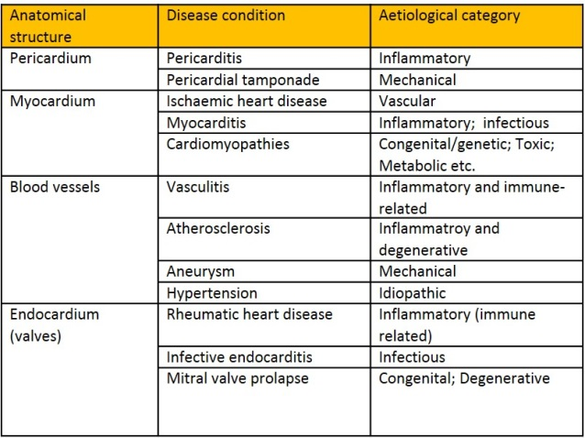
Some diseases feature more commonly within each anatomical subsite.
(This is not a fully comprehensive list)

Clinical Manifestations
(Refer to clinical text e.g. Tally and O’Connor for more details)

Localized symptoms directly from cardiac pathology:
- Chest pain (nature of which is clinically important).
  - E.g. ischemia, pericarditis
- Palpitations (e.g. in arrhythmias)

Signs/symptoms arising in other organs
- Renal induced water retention; renal impairment or failure
- Brain: cerebrovascular accident (infarct, haemorrhagic stroke – seen in poorly controlled hypertension or thromboembolism from atheromatous changes in carotid artery branches); hypertensive encephalopathy.
- Lower limbs: peripheral vascular disease (This is seen in patients with atheromatous changes and thromboembolic complications in the vessels supplying the lower limbs)
Systemic signs/symptoms
- Eg. Heart failure
- Systemic venous congestion – body cavity effusions, lower limb swelling, etc.
- Symptoms arising from pulmonary congestion and oedema (in left heart failure) – dyspnoea and some specific types of dyspnoea, cough. (read up on these)
- Fatigue, dizziness, cool extremities
- Collapse from cardiogenic shock (eg. acute myocardial infarction, sudden cardiac death etc)
- Cyanosis

- High fever (infection) – e.g infective endocarditis

Symptoms of aortic disease (thoracic, abdominal)
- Severe pain radiating to back, shock, rapid mortality. E.g. aortic dissection or rupture of aneurysm

Mindmaps:
1. Main CVS diseases overview - Function and classification
2. Atherosclerosis and ischemic heart disease
3. Hypertension and heart failure

http://blog.nus.edu.sg/pathotest2/cardiovascular-system/iv-big-picture-main-cardiovascular-diseases/

Talking POTS and slides
http://blog.nus.edu.sg/pathotest2/cardiovascular-system/cvs-talking-pots-and-slides/

Quiz
http://blog.nus.edu.sg/pathotest2/cardiovascular-system/cvs-quiz/

