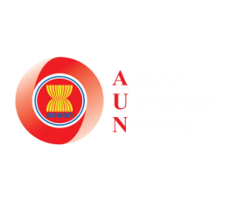

**Young Speakers’ Contest**

**Educational Forum and**

**AUN & ASEAN+3**

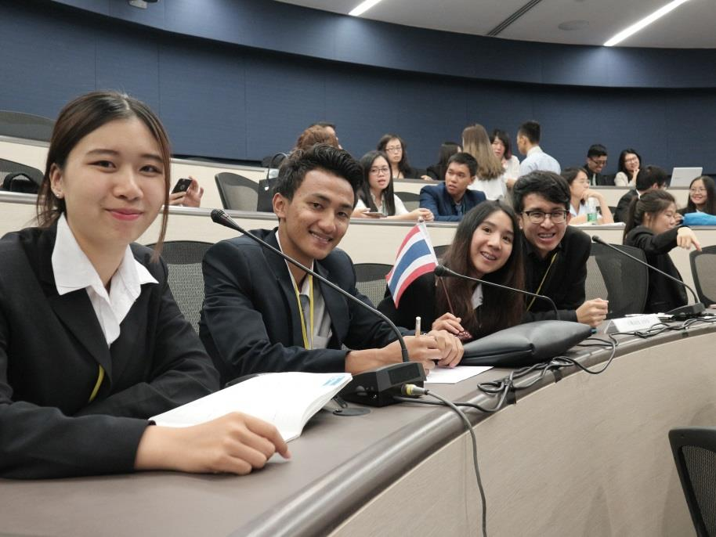

Youth is the ultimate actor that redefines our future. In order to do that, we must raise awareness of and in depth discussion on the common concerns of the public or specific issues in East Asian region, the Educational Forum and Young Speakers' Contest are launched. This activity is in line with one of the AUN’s over-arching objectives. It was initiated to promote the youth of ASEAN+3 countries, the conscience, and to provide a platform where they can voice their concerns and opinions on ASEAN +3 regional agendas.

It is a strategy to build up in-depth knowledge on the current regional & global affairs in order to catch the diversity and prepare the next generation of leaders. In 2011, the forum was expanded to the dialogue partners of ASEAN which include China, Japan, and Korea, or also known as ASEAN +3. This will allow us to be familiar not only within our own community but as well as our neighbors.

WHO ARE WE?

“This is a platform for talented youth of ASEAN and The Plus Three countries in public speaking and academic presentations.”

WHERE &

WHEN?

This forum is conducted annually and held usually in the second or fourth quarter of the year. The venue changes every year depending on the university that will host the event.

WHO CAN

TAKE PART?

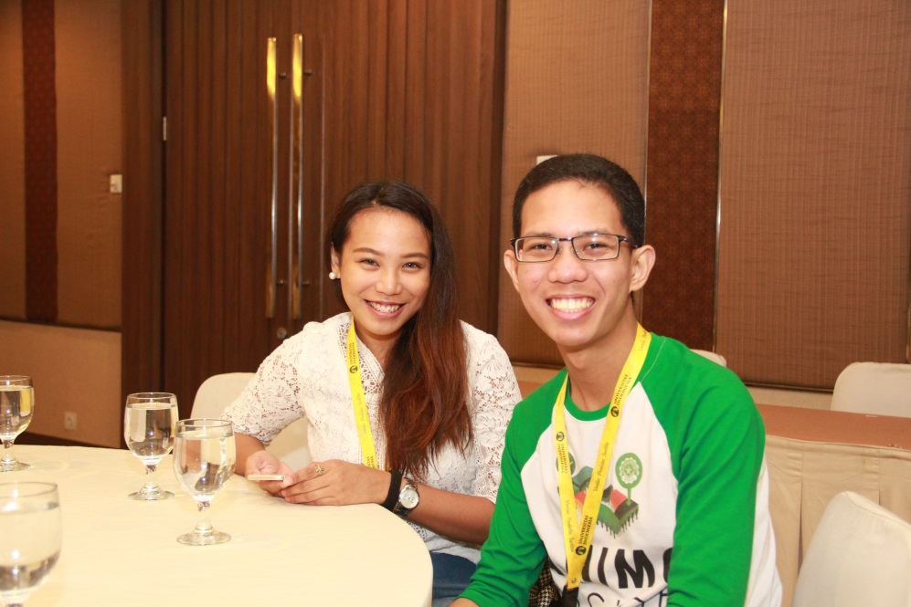

Each university sends three representatives. One undergraduate student for Educational Forum, one for Young Speakers’ Contest and one accompanying faculty staff on voluntary basis.

Here, AUN tries to promote ASEAN Awareness especially amongst the youth through cooperation among students and scholars in a way that encourages familiarity and friendship both among ourselves and with the ASEAN community.

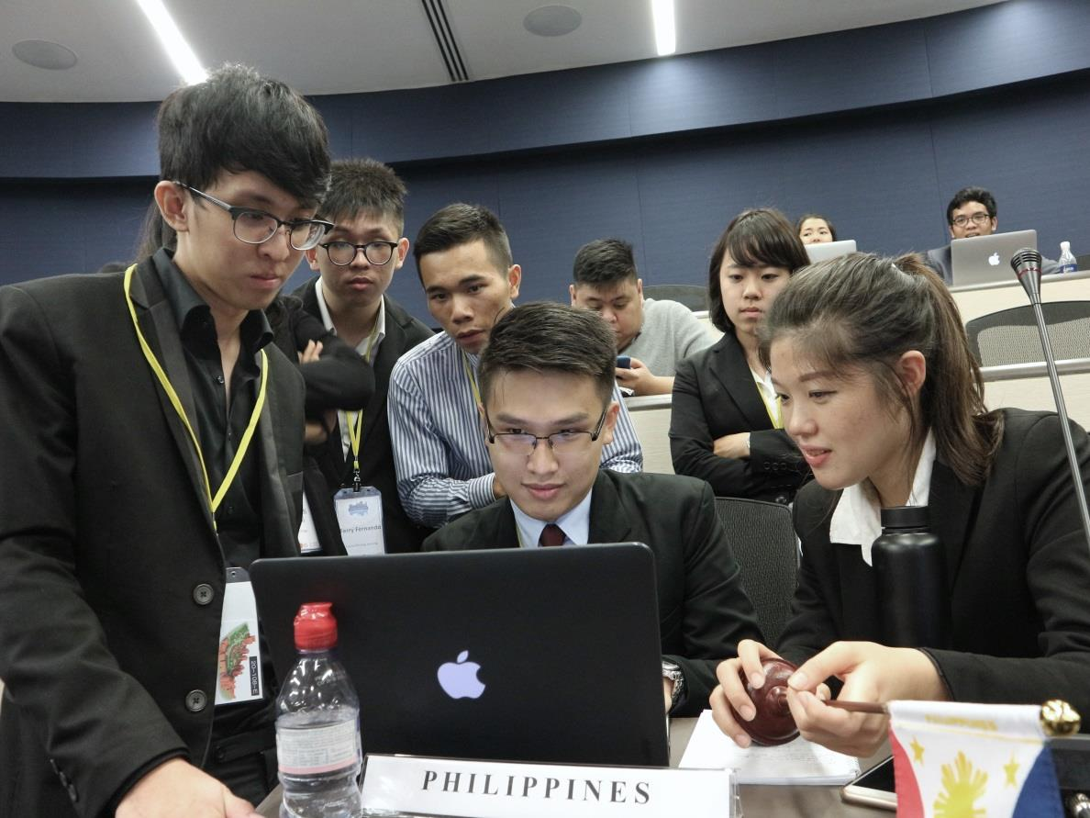

WHAT DO WE DO?

This event is executed for five days where three days is allocated for the core programme, which is Educational Forum and Young Speakers’ Contest. Below are the activities participants are going to do:

**Orientation**

This is a briefing session by AUN Secretariat for Ed Forum Participants, YSC Participants, and Faculty Staffs in order to have clear understanding on the forum procedure, rules and regulations of activities, and their roles in particular session.

**Special Lectures**

A professor or an expert will deliver these special lectures related to a theme each year which is designed by the host university and the AUN Secretariat. Special lectures should enhance knowledge and maximize understanding of the theme, which will trigger youths as young future leaders for regional challenges and stimulate cooperation among ASEAN+3.

**Educational Forum**

This forum is a simulation of an ASEAN Youth Summit. It is a platform for undergraduate students to represent their own country in voicing out their opinions that reflect their country’s position and interests towards the given ASEAN+3 related issues. Educational Forum will deploy procedures based on a combination of an ASEAN+3 Summit parliamentary procedures and Model United Nations (MUNs). In order to emphasize the ASEAN practice in the process, the delegates will work on a consensus basis.

The key activities of the forum are as follows:

1

Country Position

2

Working Group Discussion & Presentation (Sub - Theme Discussion)

3

Youth Joint Statement (Drafting, Presentation, Adoption)

**Young Speakers’ Contest**

Young Speakers’ Contest is a speech competition which aims to raise the profile of ASEAN and Plus Three countries’ cooperation among the region’s next generation of leaders and to deepen the awareness and understanding these young people have on their region’s cooperation mechanisms and their future viability.

The Young Speakers Contest is composed of two rounds:

**The final round (6 finalists)**

The student has 5 minutes to deliver prepared speech (new given topic) with 2 minutes to answer follow up question

**The first round**

The student has 5-7 minutes to deliver prepared speech

WHY SHOULD

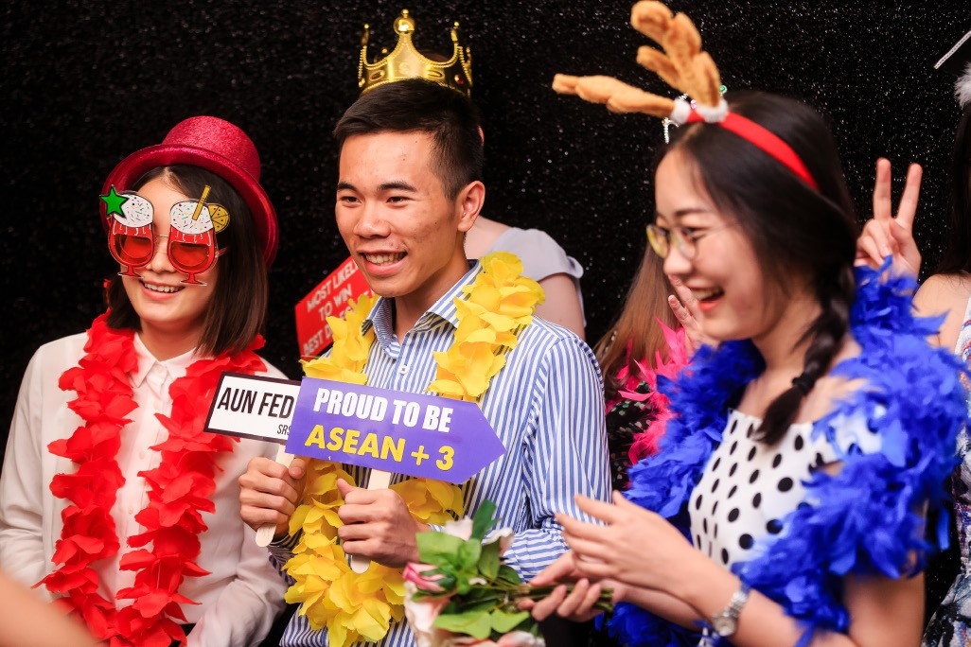

I JOIN?