Microsoft Windows Mixed Reality Hackfest
9th April to 12th April, Intercontinental Hotel, Ballroom III, Singapore

Microsoft Singapore conducted Mixed Reality Hackfest from 9th April to 12th April. Microsoft offered developers the opportunity to work on building Mixed Reality experiences that leverage Azure Services (Machine Learning, Storage, Functions, Media Services, and Cognitive Services).

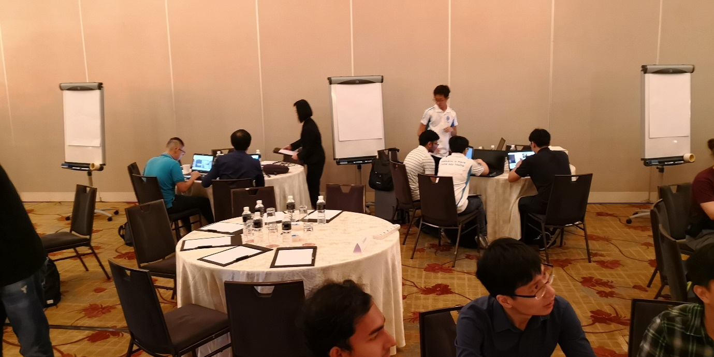

Around 7 teams participated in this event including NUS and NTU with an objective to upgrade the skills and network. All teams got to hear from the Product Engineering and Microsoft Commercial Software Engineers on Windows Mixed Reality and Azure. The teams were given code using labs designed for Mixed Reality and Azure scenarios. In addition, Microsoft engineering worked side-by-side to guide to realize the proof of concept.

NUS team was represented by staff from Centre for Instructional Technology, NUS IT and NUH. NUS team worked on the scenario proposed by Dr Alfred KOW, NUH - recognizing sharp medical instruments/tools (such as scissors and scalpels) and display the training materials related to it. Team successfully managed to develop the proof of concept within 4 days (see the link below). Dr Alfred KOW hopes to apply for the LIFT grant to develop this further for the benefit of the NUS medicine students.
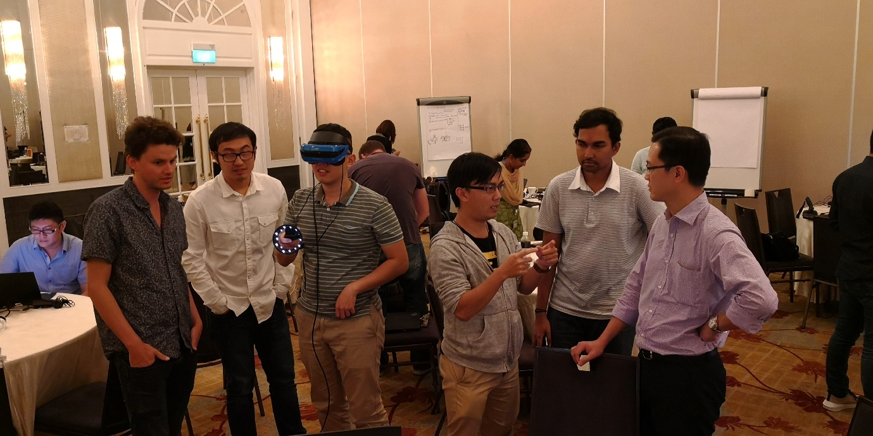
CIT staff sharing the proof of concept with Dr Alfred KOW (Right)
Proof of Concept Video (Login required) -https://mediaweb.nus.edu.sg/Panopto/Pages/Viewer.aspx?id=804c5fcb-adee-46f3-b2e9-b8063a06b740

